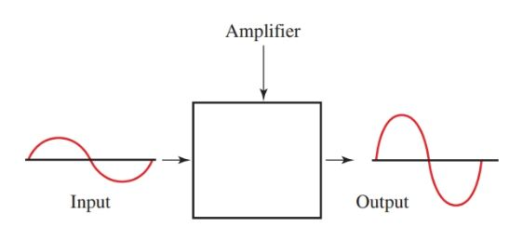

Vout

Vin

A

|  |  |
| --- | --- |
| Vin | Vout |
| 2 | 20 |
| 3 | 30 |
| 4 | 40 |
|  |  |
|  |  |

Vout=A. Vin

Hence, A = $\frac{Vout}{Vin}$ = $\frac{40}{4}= \frac{30}{3}= \frac{20}{2}$

If I say, that Vin = 1

Then A = $\frac{Vout}{Vin}$ = $\frac{Vout}{1}$

Hence, Vout=A, only if Vin=1

Now what is Vin=1  
  
step or Impulse?

δ (n)

h(n)